ANNUAL REPORT
2013-14
Vigyan Ashram
( a center of Indian institute of education,Pune)
At.Post.Pabal Dist.Pune 412403
www.vigyanashram.com

Introduction :
We are proud to present annual progress report of Vigyan ashram, for year 2013-14. We continued our work on RDES philosophy through various programs and projects. Some of the important achievements for year 2013-14, are establishment of Do-it-yourself (DIY) lab, Village level Entrepreneurs (VLE) training in Madhya Pradesh and Chhattisgarh states, new technologies development & spread of IBT program in other parts of India. We continued development of content on basic technology and contributed in syllabus restructuring of IBT program with vocational department during this year. We received Maharashtra State Livelihood Innovation Mission Forum (MSRLIM) award, Word bank- Development marketplace award and Shri.Ga.Ma.Samajik Krushilta Purskar – 2014 award in recognition of our work.
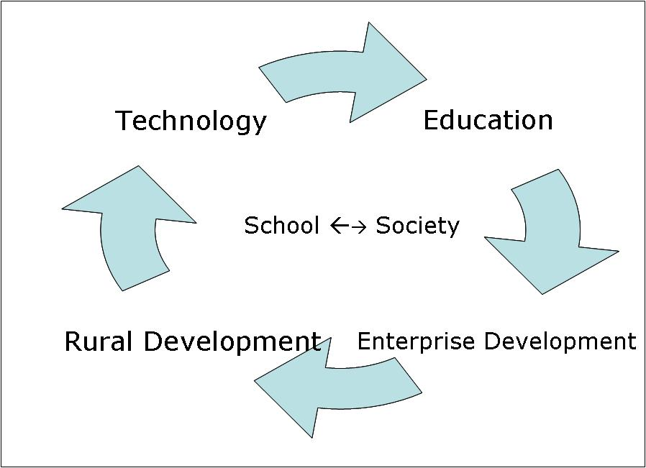
It’s our pride to have dedicated team of employees, through which we are able to achieve this. We are also thankful to all our Funding partners, IBT School, supporters and Pabal villagers who are keeping continuous faith on us. Our special thanks to Board of trustee IIE for their continuous support & guidance for our work. Progress of important project and work highlights in the year 2013-14 are presented in the report.
Vigyan ashram’s Educational Philosophy
‘Development through education and Education to development’ is a motto of Vigyan ashram. Vigyan ashram is working on the philosophy named as ‘Rural Development through Education System (RDES)’. We believe technology is needed to improve pace of our development efforts. Various appropriate technologies developed are disseminated through education program. Students learn by ‘Learning while doing’ methodology and while doing so they provide service to community at modest cost. This gives students experience and confidence to start their self-enterprises.
- Diploma in Basic Rural Technology (DBRT)
DBRT is the full time 1 year residential program affiliated to National Institute of Open schooling (NIOS). Following are important highlights of DBRT program –
- DBRT batch of 2012-13 completed on 25th June 2013, with 37 students graduating .They were placed in the area of their interest.
Vigyan ashram got recognition as Vocational training provider (VTP) Skill development initiative scheme (SDIS). With this recognition now Vigyan ashram can conduct 23 short term courses which will be supported by Ministry of labour and Employment.
- New batch of 2013-14 started on 10th July 2013, with 42 students from 8 different states as Assam, Arunachal Pradesh, Meghalaya, Andra Pradesh, Kerala, Bihar and Maharashtra.
- According to ‘Learning while doing ‘ philosophy of education ,DBRT students carried out various projects such as waste recycling , installation of drip irrigation & mulching paper in farms, fabrication and electrification works, ferro cement construction etc.
- DBRT students were also busy with their project activities, meditation & morning exercise, community services, entrepreneurship development activities and cultural events.
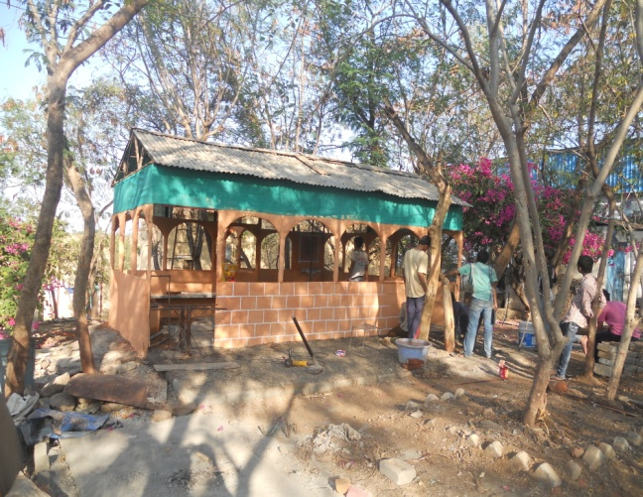
- Various short term courses, conducted on campus. Total of 47 students completed their course with following break-up as –
DBRT students project - construction of ferro-cement house (dream-house).
(Welder cum fabricator (1Year) – 14, Welder fabrication (3 month)-3, Poultry farming – 4, Goat farming- 3, Basic electrical fitting and Electric appliances repair –1, Basic accounting (Tally) – 18, Computer basic – 4)
- We have conducted training program on geodesic dome construction for architect students of Sinhgad Institute of architecture, Pune. 96 students attended this camp.

We are thankful to our supporter Asha for Education, Seattle Chapter, Gyandeep, various individual sponsors who helped us financially to conduct this program smoothly.

- Introduction to Basic Technology (IBT)-
Introduction to basic technology program is replication effort of RDES philosophy. It is being implemented in formal schools (8th-10th class). Currently this program is implemented in 130+ schools in 5 states as Maharashtra, Chhattisgarh, Karnataka, Goa and Andra Pradesh in partnership with organization as given below-
Location | Partner NGO | No of high schools | Role of VA | VA Field person location
Maharashtra, Karnataka, Goa, Andra Pradesh | Lend-a-hand-India,Vigyan Vahini,Jnan Prabodhini, Loksadhana, Wild Life conservation trust, Suzlon foundation | 107+ | Training, content development and Advocacy | Pabal (2) , Nagpur (2)
Chattisgarh | District Government of Bijapur and Dantewada Dist. | 23 | Mentoring , training, content development | Dantewada (CG) (2)
Following are the important highlight of IBT program during last academic year as –
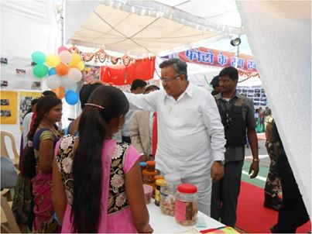
- IBT program expanded in Dantewada district of Chhattisgarh state. This year number of IBT School in Dantewada district increased to 18 schools (porta cabins) covering all district with 5400+ students’ beneficiary and 72 local youth as IBT instructors .
- In Maharashtra, presently 92 + schools are implementing IBT program with 8000+ students. These schools are spread over 27 districts connecting to nearly 300+ villages covering different geographical are such as costal belt, tribal belt and irrigated dry land areas. While implementing IBT, these schools are also disseminating 40+ different rural technologies. Some of the important technologies adopted and disseminated by schools this year are azolla cultivation, drip irrigation, bamboo processing, egg incubation, solar LED lamps, various food preservation methodologies etc.
- IBT program in Pench- Tadoba tiger reserve forest area – with the help of Wild life Conservation trust (Hemendra Kothari Foundation): IBT program is implemented in 5 schools of Pench-Tadoba tiger reserve forest area from last 3 years benefiting 750+ tribal students. Participation in different district /state level science exhibitions, providing different community services, career counseling to post-IBT students are some of the important highlights of IBT program in this area.
- IBT Trainings- Training & capacity building of IBT instructor, coordinators and school Principals are very important component of IBT programme. In 2012-13 academic calendars 207 IBT instructors from Maharashtra and Chhattisgarh state are trained for different technical and entrepreneur skills. We are happy to inform that some organizations started replication of IBT program on their own. This proves its replicability and utility.

Other important highlights of IBT program-
- IBT school principle (HM) meeting was held at JPNC Pune on 4th January 2014, to discuss various issues regarding IBT implementation as financial support, new educational policy, administrative issues etc. Meeting was attended by 76 school representatives from 46 IBT schools.
- IBT School of Dantewada district (Chhattisgarh state) participated in Rangeela Bal Mohosav , a state level students festival at Raipur. Chief Minister of Chhattisgarh Dr.Raman Singh and other state ministers visited IBT stall and appreciated IBT program.
- A ‘ 360 ̊ annual review ‘ meeting was conducted for IBT Schools in Pench & Tadoba tiger reserve forest area. Review was taken by stake holders as funding agency, Villagers, School administrate, IBT instructors, and Wild life conservation trust (WCC) and other partner NGOs etc.
- www.learningwhiledoing.in – To promote ‘Learning While Doing’ philosophy, we are developing ‘Open Education Resources (OER)’. OER developed are available on www.learningwhiledoing.in website. We are organize workshop to develop OER in collaboration with ‘Nayee Talim Samitee’, ‘Gujarat Vidyapeeth’ and ‘Azim Premji University’ at Ahmadabad in November 2013. 70 teachers across the country participated in the workshop.
- Mr.Ashok Kalbag, Dr.Yogesh Kulkarni,Dr.Arun Dxit, Mrs.Seemantani Khot worked on IBT syllabus revision committee appointed by DVET. IBT syllabus is revised as per National Vocational Educational Qualification Framework (NVEQF).
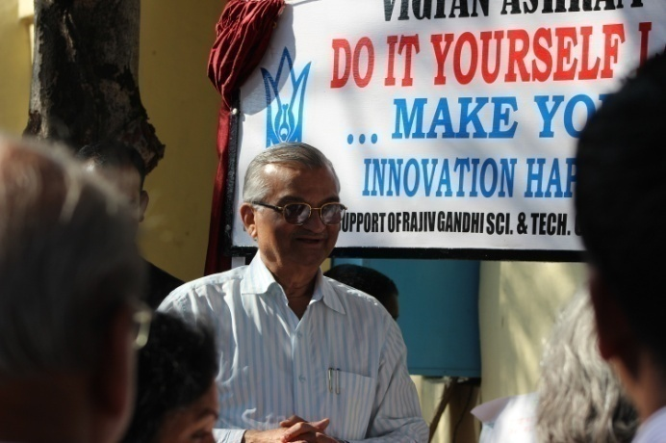
- Do-It-Yourself laboratory @ JPNC Pune
Do-it-yourself (DIY) is formally inaugurated on 10th December, at the hands of senior nuclear scientist and chairman of Rajiv Gandhi S & T commission Dr.Anil KaKodkar. Grass-root innovator Mr.Jahangir Painter (3 idiot fame) was present as Chief Guest of the function. This lab is equipped with basic tools in workshop, agriculture, and electronics. D.I.Y lab is open to all for making things of their interest. Student’s housewives and makers are presently using this lab for their idea incubation.
- Technology Development
Following are few important technologies developed / tested by core staff under DST core support -
Sr No | Particular | Introduction/ features/ Principles
1 | Domestic Solar Egg Incubator | - Temperature / Humidity control systems are modified to digital controls.  - Business model prepared for domestic egg incubator model.  - 4 Units were sold (2 to educational institutes & 2 to farmers) by M/s.Future innovatiove systems.
2 | Aquaponics | - Trial on feasibility of aquaponics is in progress.  - Trials on aquaponics with various polyhouse farming crops as cucumber, tomato, spinach are completed.  - Tomato & Cucumber trials showed significant difference in yield output of crops.  - Experiment results are published on www.vigyanashram.wordpress.com
3 | Ambient temperature dryer (De-humidifier) | - Dryer based of dehumidification principle developed for fruit pulp, vegetables, herbal products etc drying with field testing on mango pulp.  - Mango pulp dried to form candy roll, a marketable processed product.  - Commercial marketable model designed with 3000 lit volume capacity on order with its operational manuals.
4 | Food processing recipes | - Various new food recipes are developed as that of - Linseed fortified chikki, Spirulina fortified chikki, Drying technology for Natural fruit pulp, Pomegranate drying, ready mixes etc..

- Technology Dissemination
For dissemination different technologies developed / adopted to rural community following important activities / project were undertaken as
- Village level entrepreneurs (VLE) training ( Word bank supported development marketplace project) –
Vigyan ashram own ‘India Development Market-place (IDM) 2013 award from word bank. This is competitive funding of $100000 received in function held in Bhopal on 1st May 2013. VA participated in collaboration with ‘Bottom of the Pyramid Energy & Environment Pvt Ltd (BOPEEI). We are planning to train 300 village level entrepreneurs (VLE) in Madhya Pradesh (MP) and Chhattisgarh (CG). They will provide LED lightning solutions using solar & human power generators. We are also established 100 demo centers in Schools in Madhya Pradesh and Chhattisgarh.
- Skill on Wheel (SOW) –
SOW is the research oriented rural skill training project started with the aim of developing effective, affordable model for providing skill training rural community. During this year various rural technology based training activities were conducted under this project in collaboration with various partner organizations as Snehalaya (Ahmadnager), Chaitanya (Rajgurunager) , Paulwat (Velha), Srinivas seva trust (Shirur) etc. On the field training and monitoring supporting was provided through need based training modules of various skills as Azolla cultivation, dairy farming, food processing, nursery techniques etc to more than 70 beneficiaries including rural youth, SHG members. We are trying to develop training protocol for various skills. Dr.Sudhir Praphu is sponsoring the project and we are thankful to them.
- INDUSAPTI-
INDUSA Practical Training Institute (INDUSAPTI) is online platform for development, publishing and testing of various educational resources. Following important activities are conducted under this project as -
- The content development work on rural technologies is continues activity. Open Educational resources (OER) PPT’s and video’s developed are available online on www.learningwhiledoing.in website.
- Technology publication work – Updates on various technology development work at Vigyan ashram are regularly posted on www.vigyanashram.wordpress.com , this blog attracts many visitors. We have 19660 hits in the year and lot of comments / feedbacks by online viewers’. We are regularly maintaining www.dsttara.org. This is rural technologies portfolio website of DST supported organizations.
- AAKASH Tablets – IIT,Pawai has given us 200 Aakash tablets for testing with IBT School children. These tablets were distributed among 8th std IBT students of Shri.Bhairavnath Vidya Mandir,Pabal. We have also loaded content developed by us on Aakash tablets. We are taking monthly feedbacks of use of the tablets.

- Infrastructure development
- INDUSA CARE – New computer lab established under INDUSA CARE (Computer application for rural Education) project. This lab is equipped with network PCs, wi-fi connectivity and training facility for 20 students. Various computer based skill courses and community services in basic accounting (Tally), basic hardware assembly & computer maintains services etc facilities are provided by this centre to nearby villages and schools.
- Reconstruction of Kitchen-cum-office building- Plan reconstruction of building at Vigyan ashram campus are finalized with design drawings and other requirements. Dr.Bhatia of INDUSA endowment are supporting this re-building cost and we are planning to start it my mid of June 2014.

- Workshops/ Seminars/ Exhibitions
- Workshops-
- Nayee-Talim Samitee organized workshop to prepare ‘OERs to implement learning through productive work activities’ at Gujarat Vidhyapeeth , Ahmadabad during 18th to 22nd November. Vigyan ashram participated in this workshop as technical partner for developing OERs on different rural technologies along with Azim Premji University, Gujarat Vidhyapith and Nayee Talim Samittee.
- Vigyan ashram hosted STAR’s forum (Skill training for advancement of rural society) 4th annual conference on 28th & 29th December. Total 112 participates from 6 states representing 90 different organization covering 6 states participated. Conference theme deliberated on topics as new livelihood opportunities for rural area, rural marketing, skill training modules, work base education etc.
- Ms.Adwaita and Anita attended 3 day workshop on NGO management arranged by SPJMIR institute from 21st to 23rd August.
- Seminars –
- Dr.Yogesh Kulkarni attended International Conference for Digital Fabrication (Fab9) at Yokohama, Japan from 21st to 28th August. He also presented paper on “Egg incubator” developed at Vigyan ashram.
- Ranajeet Shanbhag visited National University of Singapore (NUS) during 13th to 17th August to attend project review meeting of COSMIC project. Vigyan ashram is working partner agency with NUS in developing mobile phone based pest management system for rural farmers.
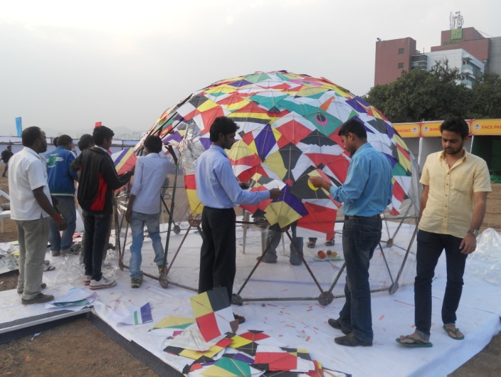
- Mr.Ashok Kalbag presented paper on Vigyan ashram in ‘Tech for Seva’ conference in Pune in September 2013.
- Open house Exhibition – Open house exhibition was organized on 30th July 2013, on the occasion of 10th anniversary of Dr.S.S.Kalbag. Exhibition of all our project and major achievements was displayed.This years ‘Yuva Udyojak’(Young Entrepreneur) award was given to Mr.Avinash Gavari (2004 batch DBRT student) at the hand of our senior alumni Mr.Pandharinath Manmode. More than 3000 visitors including local school trips, college students, our alumni, villagers, farmer’s club members, local political leaders visited exhibition.
- DBRT students and staff participated in various sciences & technology based exhibitions as that of GMRT khodad science fair, Sakal-agrowon agricultural exhibition, Pune Kite festival etc
DBRT students erected dome structure in Pune Kite exhibition at Balewadi.

- Awards/ reorganizations
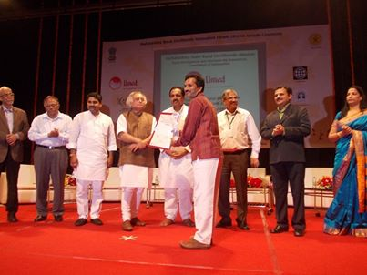
- Vigyan ashram and BoPEEI Pvt.Ltd. received Word bank sponsored International Development market place award- 2013, for replicating renewable energy technologies in tribal belt of Madhya Pradesh and Chhattisgarh state.
- Vigyan ashram received “Maharashtra State Rural Livelihood Innovation Mission Forum” (MSRLIMF) award for IBT program for dissemination of rural technologies rural areas. Award amount of Rs.2.0 lac and trophy was presented at the hand of rural development minister (Govt of India) Mr.Jayram Ramesh at function held at Mumbai.
- Vigyan ashram received Shri.Ga.Ma.Samajik Krushilta Purskar – 2014 for its efforts of rural development. This award is presented in the memory Late Shri.Majgaonkar (Editor of well-known Marathi Magazine ‘Manus’).
- Maharashtra tourism development corporation (MTDC) included Vigyan ashram in its social tourism destination.
Many volunteers from various institutes / organizations as Engineers without border (EWB-UK), SPJIMR- Mumbai, Dr.BSKKV Agriculture B.Tech College, Fab-lab (MIT – USA), Bachpan Banao (CG) and individual volunteers contributed in Vigyan ashram’s program during last year. We are thankful to them for their valuable contribution.

- Management committee meetings
The management committee consisting of Mrs.Mira Kalbag, Mr.Vijay Kumar, Mr.Sunil Kulkarni, Dr.Yogesh Kulkarni, Mr.Ashok Kalbag, Mr. Mahajan, Dr,Aruna Giri, looks after strategic, administrative and financial matters of Vigyan ashram’s programs. Meetings of MC were held on 9th June 2013, 30th July 2013, 12th October 2013, and 22nd March 2014. Vigyan ashram is thankful to management committee members and Board of Trustees of Indian Institute of Education (IIE) for their support and guidance.

Vigyan Ashram Annual Financial Report 2013-14
Sr.No | Project Name | Fund Received | Project Expences
1 | ADRA PROJECT | 0.00 | 0.00
2 | ASHA PROJECT | 760000.00 | 802383.00
3 | BAYER PROJECT
4 | BRIDGE LOAN PROJECT
5 | CORE PROJECT | 962975.00 | 1525406.00
6 | DIY Project | 13727.00 | 730150.00
7 | GKN PROJECT |  | 2300.00
8 | HKF PROJECT | 700675.00 | 893825.00
9 | IBT CHATTISGAD | 296560.00 | 270147.00
10 | PLAN 100 PROJECT | 222500.00 | 417202.00
11 | SUZLON PROJECT | 100000.00 | 80244.00
12 | IBT BOOK PRINTING EXP
13 | Indusa Project |  | 328377.00
14 | New Staff Room Contraction |  | 56543.00
15 | OLEORESIN SEPARTION PROJECT |  | 2300.00
16 | PRAJ PROJECT | 200000.00 | 239888.00
17 | STAR FOURAM | 442000.00 | 208175.00
18 | TELEPHONE AND MOBILE CHARGES |  | 23375.00
19 | VIGYAN ASHRAM ACTIVITIES | 1827074.00 | 1951773.50
20 | MSEDCL -VA |  | 160400.00
21 | KITCHEN & OFFICE RECONSTRUCTION | 1210000.00
 | Grand Total | 6735511.00 | 7692488.50
22 | WORLD BANK DM PROJECT | 6309248.00 | 1445647.00
** VA account do not have opening balances of each project before April2013 in Vigyan Ashram's Tally records. This fig will be reflected when the account merges with IIE Accounts.
** Record presented is as per Tally records maintained at Pabal.
 | ** This do not have interest on VA corpus and IIE a/c expenses.
 | *** Account is unaudited

