WATER PUMP CONTROLLER
PREPARED BY

Table of Content

Scope of the problem: 3
What we can do..? 3
The Device -Water Pump Controller/Alarm System- 3
Circuit Diagram: 4
Board Files: 4
Circuit Description: 4
Technical Details 5
Components Used:- 5
1. Transistor BC547 5
2.7805 Voltage Regulator: 5
Material list and tentative price: 5
Enclosure: 6
Scope ahead: 6
Propagation: 6
References: 7
Document History: 7

Introduction:
Water is an essential part of our life, without this survival will become difficult for all. As it is very necessary for all living beings on the earth, it is very important & very useful for our daily life & it also being used in industries & power plant. Hence it is very necessary to save the water to fulfil our future needs.

Scope of the problem:
People have less awareness about the water uses. In many homes, apartments & in industries, tanks are provided with outlet pipe from which water gets out of the tank when tank gets full. But in this method lot of water gets wasted.
It also depends on the person who operates the motor or a valve, if it delays then more water gets waste. Second thing is, one need to always monitor the tank that is it filled or not which consumes time & human resource as well.

What we can do..?
For the above problem we propose a low cost pump controller device which will change the state of motor from ON to OFF as tank gets full. By means of this we can save the water which gets wasted after tank gets overflowed.

The Device -Water Pump Controller/Alarm System-

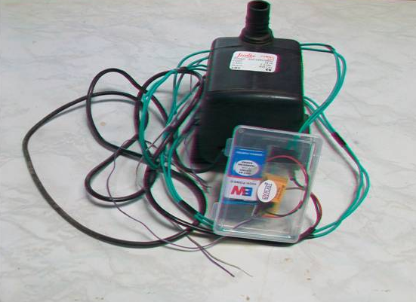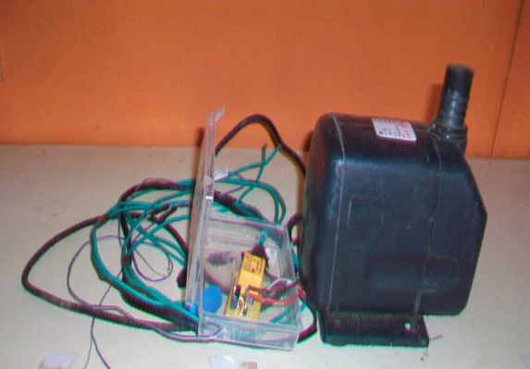
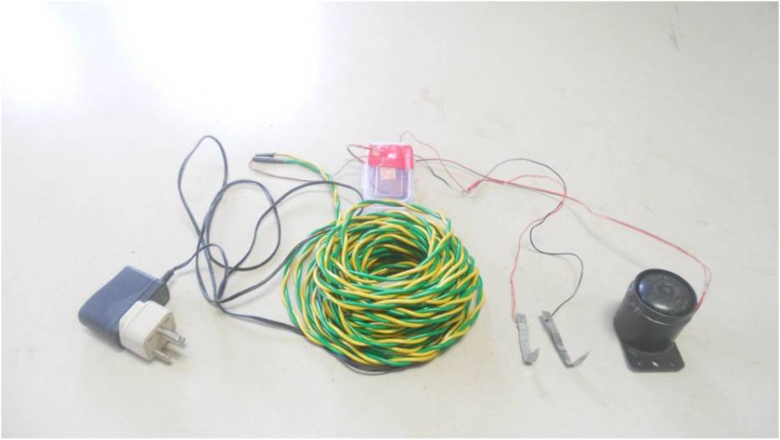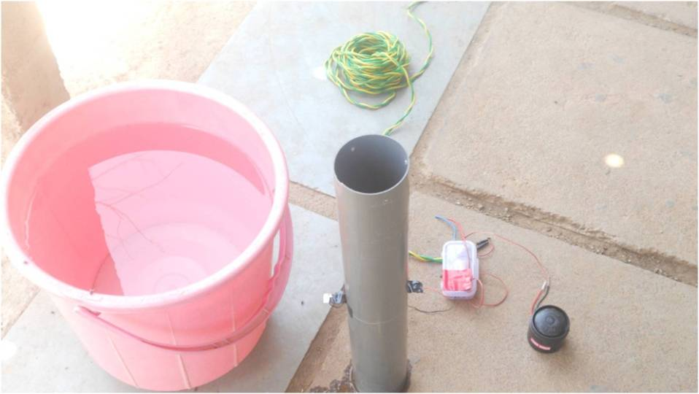

Circuit Diagram:
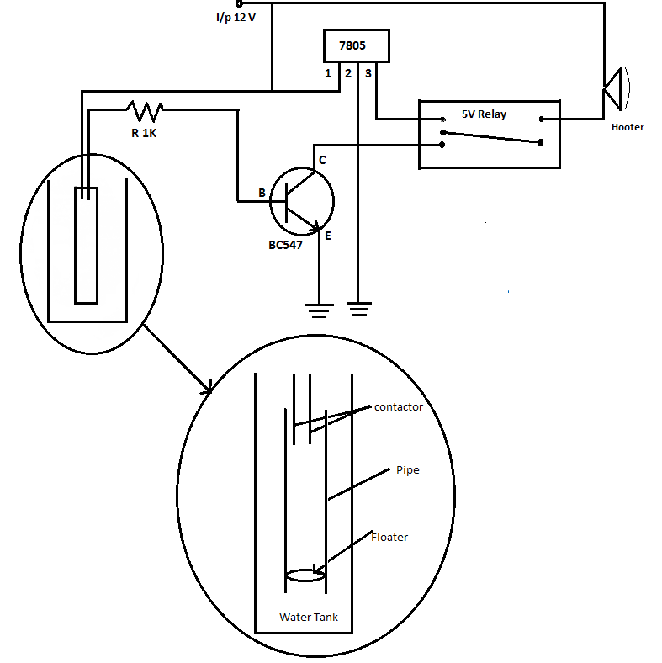

Board Files:
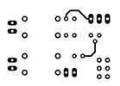
TOP SIDE BOTTOM SIDE
Please find the above Board files on the following link:
http://www.scribd.com/doc/160935401/Waterpump-Board-File

Circuit Description:
Two wires in the tank act as sensor, as water reaches up to the wires, current carries by one wire is transferred to the second wire through water. Second wire carries the signal and gives it to the transistor BC547. Here transistor BC547 act as a switching device.
As it gets the signal at base, it operates a relay which is powered by 5V DC supply through collector. As the status of relay gets changed the motor connected to 230V AC Supply gets disconnected & motor shut downs.
We found some fault when water reaches up to wire, is that the conductivity get changes due to type of water. As water will be hard water or soft. Hence we proposed mechanical assembly by means of which problem get solved. In this assembly we used floater, pipe etc. Floater consist of wooden part as a base and conducting part is copper plate and put inside the pipe, conductive copper plate is pasted on it.
Now that floater floats on water. as water level increases, floater level also increase simultaneously and it shorts the two wires which act as sensor. Because of the hollow plastic pipe, floater disc moves only in upward direction.

Technical Details

Components Used:-

1. Transistor BC547
BC547:-is a plastic package general purpose NPN transistor which is commonly used for switching & amplification purpose.
Note: - Please Refer data sheet of BC 547 for more details.

2.7805 Voltage Regulator:
It is used to regulate the output voltage. It gives 5V DC voltage to the circuit. It can take input voltage upto 25V DC.

Material list and tentative price:
Components | Quantity | Rate (Rs) | Price (Rs)
BC547 | 1 | 2 | 2
Voltage Reg. 7805 | 1 | 15 | 15
5V Relay | 1 | 20 | 20
Resistor (1K) | 1 | 1 | 1
9V Battery | 1 | 10 | 10
Wires | 1 (M) | 7 | 7
Soldering Metal | 60 (cm) | 5 | 5
Enclosure | 1 Set (6 Pieces) | 140 | 140
 |  | TOTAL | Rs.200

Enclosure:
Please find the above enclosure file on the following link:
http://www.scribd.com/doc/160928528/Water-pump-Controller

Scope ahead:
A few modifications can be done with the present system like,
1. It can be supplied with low level senor, which will tell us that water level
goes down & on basis of this input, motor gets on.
2. Rechargeable Power supply instead of non-rechargeable batteries.
3. Better Casing or Enclosure for easy handling & tough weather condition.

Propagation:
We want this system should be adapted by the communities living in rural, urban & city areas to prevent the water from going waste.
We also want the awareness about water saving should spread among all especially children’s as they can save more water in their whole life.
By means of this we can also save electricity as motor gets OFF at right time.

References:
www.alldatasheet.com
http://inkscape.org/doc/basic/tutorial-basic.html
http://www.cadsoftusa.com/training/tutorials/

Document History:
Index | Date | Author | Modification Made
1 | ‘March 16,2013 | Vigyan Ashram | Document Created
2 | ‘April 1,2013 | Vigyan Ashram | V_1.0 Completed
3 | ‘April 12,2013 | Vigyan Ashram | V_1.1 Completed
4 | ‘Aug 08,2013 | Vigyan Ashram | V_1.2 Completed
5 | ‘Aug 17,2013 | Vigyan Ashram | Board Files Added

