ANNUAL REPORT
2014 -15

Vigyan Ashram
(A center of Indian Institute Of Education)
At.Post.Pabal Dist.Pune 412403
www.vigyanashram.com

Introduction:
We are pleased to present annual progress report of Vigyan ashram, for year 2014-15. We continued our work on RDES philosophy through various programs and projects. Important projects completed/started are as follows :-
- More than 300 individuals’ donor contributed to fund reconstruction of kitchen in response to article in Marathi daily ‘Loksatta’. Reconstruction work of kitchen and administration office was completed in Dec 2014 with this generous support.
- A new ‘Entrepreneurship Accelerator’ Department is started in VA. It will focus on mentoring and providing business support to our alumni’s.
- World bank funded ‘India Development Marketplace’ project got completed. We have trained 370 energy entrepreneurs in MP and Chattisgarh. We are also able to establish 11 solar grams in MP with the World bank funds.
- We have started Fab Academy course. This is mix of video conferencing lecture plus hands on project course run by Fab foundation.
We are thankful to all our Funding partners, IBT School, supporters and Pabal villagers who are supporting us in our every endeavor. Our special thanks to Board of trustee IIE for their continuous support & guidance for our work. We are proud to have dedicated team of employees and volunteers who are carrying forward the mission of ‘Rural Development through Education System (RDES)’
Vigyan ashram’s Educational Philosophy
‘Development through education and Education to development’ is a motto of Vigyan ashram. Vigyan ashram is working on ‘Rural Development through Education System (RDES)’ philosophy of Dr.Kalbag. We believe technology is needed to improve pace of our development efforts. We can train our people on technologies through education. We believe ‘Learning while doing’ methodology is a natural way of learning. We can integrate development work and education to give meaningful education. It will develop creativity and entrepreneurship in our students. This will leads to rural development.
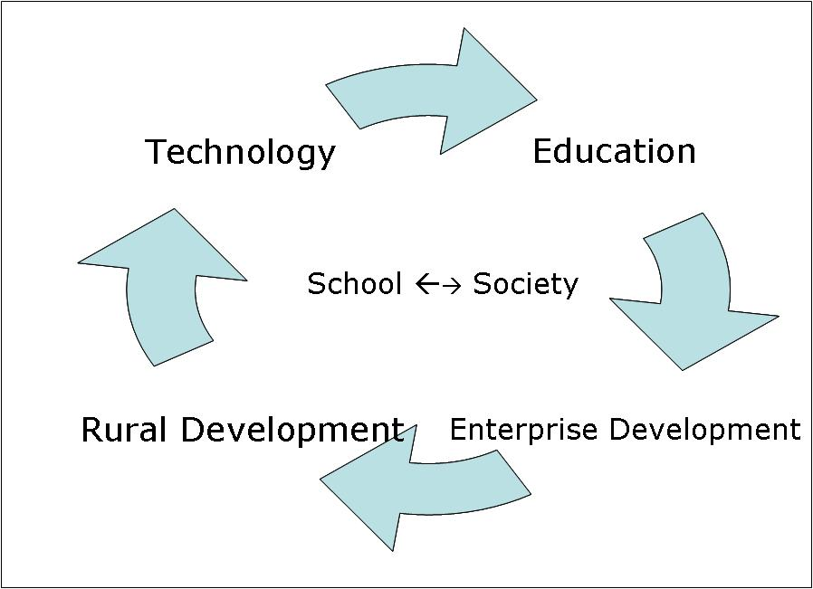
Projects and Partners :
Following are important programme undertaken by Vigyan ashram with the support of different partners during the year 2014-15 -
S.N. | Supporting partner | Project
1 | Department of Science &Technology (SEED Division) | Appropriate technologies development & dissemination under - Core Support programme.
2 | Department of Science &Technology ( NSTEDB Division) | Technology based rural enterprise development. (Entrepreneurship Accelerator Centre) .
3 | PRAJ Foundation (Pune) | ‘IBT Model Schools’ project.
4 | PRAJ Foundation (Pune) | Technology Incubation Enterprise Development Project
5 | Chhattisgarh Government and UNICEF | IBT replication and vocational training in tribal area of Bijjapur and Dantewada district of Chhattisgarh state.
6 | Hemendra Kothari Foundation ( Wildlife conservation trust – Mumbai) | Replication of IBT programme in Pench reserve forest area.
7 | Suzlon Foundation | IBT replication in Suzlon windmill project-oriented schools
8 | Rajiv Gandhi Science Commission, Govt. Of Maharashtra. | Do it yourself Lab for students @ JPNC , Pune
9 | Maharashtra Knowledge Foundation (Pune) | Developing Open Educational Resources(OERs) on rural technology.
10 | World Bank(Development-Marketplace-2013-14) | Developing Village level entrepreneurs (VLE) in Renewable energy lightning solutions.
11 | Asha for Education | Diploma in Basic Rural Technology (DBRT) training project.
12 | Asha for Education & INDUSA Endowment | New Kitchen building construction work.
13 | Loksatta news paper readers, Individual donors, Tata Trust | students sponsorship, tools, equipments, sport equipments , voluntary services etc.

A] Diploma in Basic Rural Technology (DBRT)
- DBRT is one year full time residential programme, recognised by NIOS (National Institute of Open Schooling). In 2013-14 , 36 students has successfully completed the course (out of 45 admissions). 21 placed for apprenticeship in various fields like agriculture , fabrication, electrification etc. Two (2) students joined as ‘Technician’ at IIT-Pawai FAB LAB. Remaining are perusing future studies.
- New DBRT batch (2014-15) was started from 10th July with 54 new admissions. We have students from Maharashtra, Chhattisgarh, Madhya-Pradesh, Tamilnadu state and Nepal in this batch.
- Students of Vigyan Ashram provided community services of Rs.124260/- in year 2014-15.
- The years on Pabal campus was busy with various cultural activities, picnic, celebrations and classes through out the year. Details on www.facebook.com/vigyan.ashram.pabal
- DBRT trainers also conducted various short skill training courses for rural youth , SHG members , farmers etc.

Details of the course are as -
S.N. | Type of Programme and Topic | Duration | Name of course training (Number of trainees)
1 | Short term vocational courses conducted in Pabal campus. | 1 to 3 Month | Welder fabrication – 4, Basic electrification- 3  Digital fabrication- 3,Food processing- 12  Poultry farming – 1 ,Basic accounting (Tally) –4,Dairy farming – 12
2 | Skill training courses at Livelihood college, Balarampur, Chhattisgarh. | 15 to 30 days | Bag Making – 25,Banking and accounting - 55  Basics of Solar Energy & System Installer- 15  Basics of solar electricity -30

Asha for Education, TATA motors, Mr.Darshan Wadhava, Members of Soham Ganesh Kusum Samuh, Elisabeth & Daniel Erasmus and many individuals have supported DBRT programme by supporting partial cost of the program, scholarship to needy students, tools for DBRT workshop etc. We are very thankful to them.
B] Introduction to Basic Technology (IBT)
Introduction to Basic Technology (IBT) is implemented from class 8th to 10th in formal schools. The program was developed by VA in 1987 and evolved over the period as a robust model of pre-vocational program in secondary school. In 2014-15, we have given special emphasis to improve quality of the programme by providing trainings to instructors, improving infrastructure at school level and content development & delivery based on “design thinking” approach. Efforts were also made to provide hand-holding support to schools administration to achieve sustainability.
Sample projects / community service activities / Awards by IBT Schools -
- Students of 8th& 9th class of Dhamari School (Pune) conducted health check-up for approximately 200 families in village as part of their under ‘ शालेय आरोग्य मित्र’programme.
- In Kuakonda Schools of Dantewada district (Chhattisgarh state) did electrical wiring of 5 class rooms.
- Amkhel School (Nandurbar) fabricated tree guards worth Rs.4000 in workshop department.
- Students of Dhanaji Nana Vidyalya, Khiroda (Jalgaon) did energy audit for their schools and made clap switch as learning activity.
- Students of Tanduwadi (Satara) IBT School earned net profit of Rs.7926 by cultivating Onion & Merry gold crop.
- “दिया जलाओ मच्छर भगाओ” (Mosquito repellent) project of “Shree PandharinathVidyalaya and Jr. College, Pokhari” IBT School selected for national level science competition.

Important activities this year are -
- PRAJ Foundation supported model School project :
IBT programme is spreading in Maharashtra and other states rapidly. Many organizations and government are adopting the model. Therefore Vigyan Ashram is now focusing on improving quality of implementation. “IBT model schools project” is started in 16 selected IBT schools. This project is funded by Praj Foundation (Pune) and aims to improve quality of implementation while achieving sustainability. These Schools will act as role model by achieving excellence in different pre-set performance indicators for other Schools to follow.

- Advocacy efforts :
Following efforts were taken by Vigyan ashram with Govt for replication of programme: -
- Dr.Yogesh Kulkarni,Mr.Ashok Kalbag, Mr.Arun Dixit, Mrs.Seema Khot were worked on the committee appointed by Directorate of Vocational Education and Training(DVET) to revise IBT programme as per National Skill Qualification Framework (NSQF).
- Dr.Yogesh Kulkarni, Mr.Ranajeet Shanbhag and many of our IBT instructors & teachers contributed to write books as per the new syllabus.
- Representations were made to various Government officials & ministers to introduce IBT as part of NSQF.
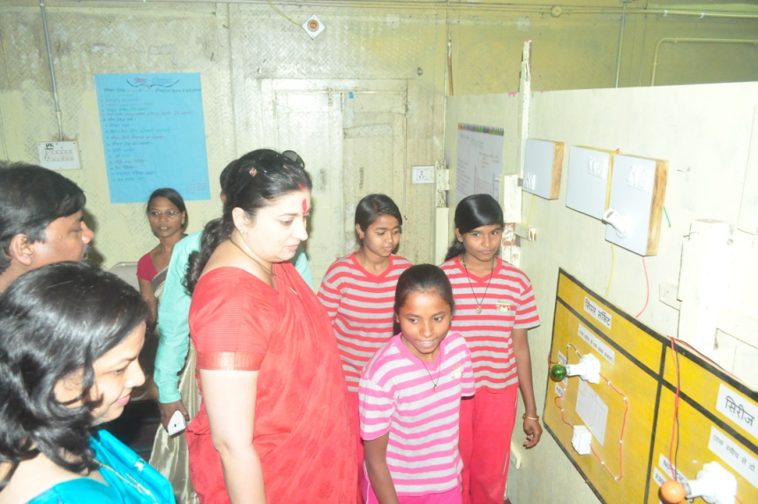
- Dr.Yogesh Kulkarni & Mr.Ranajeet Shanbhag presented a paper at ‘International conference on emerging trend in VTET’ organized by PSS central Institute of Vocational Education, Bhopal in Feb2015.
- Maharashtra government recommended IBT programme to be included as a part of core subject according to GR.NO.व्य.शि/२०१४/प्र.क्र/८२/ १४/एसडी-६.

- IBT school annual HM meeting :
Annual meeting of IBT School Head Masters was held at SantYadavbabaVidyalaya, Shindavane’ on 3rd January 2015. The meeting was attended by 57 IBT School principle and funding agency partners. Govt officials Dr.Suvarna Kharat (Project Director RMSA),Mr.Shrinivas Shastry
Honorable MHRD minister Ms.Smriti Irani visited IBT KarliPota cabin School in March 2015
(Jt.SecretaryEducation ) , Mr.Rajendra Ghume (District Vocational officer) attended this meeting .Issues like new GR, course recognition , funding, infrastructure norms etc were discussed.

- Instructors training :
Training IBT instructors is very important activity to replicate the programme. Major focus of training this year was to bring “Design thinking” approach in teaching and introduce new appropriate technologies as community service activities. Following training programme were conducted this year-
Training programme | Number of instructors
IBT instructor training Dantewada (Chhattisgarh) held during 1st-14thMay & 19th June -2nd July AND 1st to 8th November. | 115
Senior IBT instructor training (Maharashtra) held during 11th to 16th June. | 51
New IBT instructor training (Maharashtra) held during 1st to 5th November. | 29
“Design thinking “teaching approach 2 days workshop held during 17th to 18th October. | 31

IBT programme is supported by Praj Foundation, Suzlon Foundation, Wild-life Conservation Trust, UNICEF- Chhattisgarh, Lend-a-hand-India, INDUSAPTI , Maharashtra Knowledge Foundation.
C] Appropriate technologies development and dissemination
Vigyan Ashram is continuously working development and dissemination of appropriate rural technologies. The program is supported by Department of Science and Technology (DST) under its core support. First phase of the core support was completed this year. We have submitted proposal for 2nd phase of core support. DST expert committee reviewed the proposal, carry out site visit and gave sanctioned for supporting Vigyan Ashram for next 5 years.
- New technology development work :
Following are important technologies developed under DST and Praj Foundation support during Year 2014-15
Sr No | Technology | Highlights
1 | Rice- De-husking machine | Rice De-husking machine developed for producing brown rice at domestic level (cottage scale operation). First version of power operated (1 HP motor) machine was released in March 2015 and 3 units were sold to local SHG’s.
2 | Drying technologies for local vegetable. | Trials on development of drying technology package for local vegetables like onion, leafy vegetables, moringa etc. Studies were conducted to test feasibility of various drying technologies like improved terrace drying, solar drying, de-humidifier etc.
3 | Food processing recipes | New food processing recipes like Drumstick (Moringa) leaves powder, Whole wheat healthy biscuits, ready mixes are developed with its business models & packaging.
4 | WOMA-VIVUS FAB Incinerator (Sanitary Pad incinerator) | Lab trials were successfully conducted for personal device developed for disposal of sanitary pads. This device incinerates used sanitary pad / napkins in 3-5 min without producing smoke / odor. Prototype is ready; technology will be ready for field trials.
5 | Innovative agricultural tools / equipment’s as per local need | Following innovative agricultural tools / equipments / hand gadgets are developed per local need of farmers- i) Balhirda(Terminaliachebula) cutter.ii) Mahua(MadhucaLongifolia) flower collecting umbrella. Iii) Tractor mounted HTP pump. Iv) Poulty feed grinder cum mixture.

- Technology dissemination :
- 4 Units of Domestic egg incubator were sold to small entrepreneurs. It is being manufactured & sold by our alumni entrepreneur M/s.Future Innovative System.
- Technologies viz. manufacturing of processed food products, Azolla farming, Soil analysis, Poultry farming etc were disseminated by conducting awareness camps for SHG, farmers groups. More than 150 SHGmembers and farmers attended these workshops.
- DST core staff also conducted training workshops under Do-It-Yourself lab project at JPNC, Pune. More than 400 Students attended these training workshops and learned basic electronics skills and programming with Raspbery-PI, assembling LED lamps, using various workshops tools like vinyl cutter,modula,laser cutter etc.
- All our technologies and its designs are available on www.vigyanashram.wordpress.com. This blog is been appreciated by many viewers with their suggestions, feedback’s and enquiries on technologies. We received around 17000+ hits to this blog from all over the world.
- Vigyan ashram is maintaining website of technologies developed by DST supported organizations (www.dststara.org). These are 26 organizations and 50+ technologies presented on the portal.

D] World Bank supported IDM 2013 project
A project to train Village Level Entrepreneur (VLEs) in assembly, sales and after service solar LED lamps was conducted in Madhya-Pradesh and Chhattisgarh state. Under this project, we have trained 370 rural youth and sold 3000+ solar lamps benefiting around 18400 individual beneficiaries during 2013-14 and 2014-15 Years. Throughout this project, we have established 11 Solar grams (villages) in MP. These are the villages with 100 % household using solar LED lamps sold by our entrepreneurs.
E] Entrepreneurship Accelerator programme
I) We have started a department ‘Enterprise Accelerator’ to support our alumni & IBT instructors to start their enterprises. This year we have done mentoring & handholding of 34 alumni to make their business plan. A training workshop on ‘rural enterprise management’ was conducted for these selected alumni in collaboration with ‘I-create Pvt Ltd’ to provide basics skill on business management.
II) We have also entered into MOU with micro-finance organizations ‘Rang De’ to provide microfinance TO our alumni to start their business. Proposals of 4 alumni’s are in advanced stage of approval to get loan by March 2015. This programme is supported by DST under its STED (Science & Technology based entrepreneurship Development) scheme of NSTEDB (national Science and Technology entrepreneurship development board).
iii) Rural enterprise fellowship programme -A fellowship programme for budding entrepreneur started with financial and technical support from Praj Foundation. A fellowship for 6 months will be provided to alumni of VA. During fellowship tenure fellows will stay in Pabal campus and work on technology development project of his/her selected area of enterprise and made a business plan. He will be provided hard and soft skill training on rural enterprise management, marketing. He will be linked to micro-finance agencies. During 2014-15, 4 fellows admitted for this programme and they are in final stage of starting their enterprise.
Technology development & dissemination work is supported by Department of Science &Technology (DST, New Delhi) & PRAJ Foundation
F] Conferences and Publications
- STAR’s Forum 4th annual conference
Vigyan ashram hosted 4th Annual conference of “Skills Training for advancement of Rural Society (STARs) forum”. This forum is collaborative body of different skill training institute for mutual support and NGO’sand innovative approach. The conference was held on 27th to 28thDecember with the theme of ‘Livelihood opportunities in rural areas’. Total 86 NGO participants representing 13 states participated in the conference.

- Important publications and speeches -
Some of the important publications during Year 2014-15 are as follows –
Sr.N | Title of Paper | Name of Authors | Journal with Vol./No./year/page no.
1 | Keys to success of skills training in schools : Multi- skill Training and Ashram Experience | Dr.Yogesh  Kulkarni | Presented at –“International Conference On Emerging Trends in TVET vision 2025” PSSCIVE, Bhopal, India.
2 | Open Education Resources (OERs) for improving quality of skills training in secondary schools | Ranajeet Shanbhag | Presented at –“International Conference On Emerging Trends in TVET vision 2025” PSSCIVE, Bhopal, India.
3 | "Reducing Evaporative Water Losses from Irrigation Ponds Through the Re-Use of PET Bottles” | Ranajeet Shanbhag | Submitted to- Journal of Irrigation and Drainage Engineering
4 | Aiming for work centric education: IBT program in secondary schools in Maharashtra. | Dr.Yogesh  Kulkarni. | Published in - Learning Curve issue XXIV March-2015 by AzimPremji University

3) Following important trainings workshops / conferences attended by staff during 2014-15
S.N | Name of training / conference | Attendee | Topic of training
1 | International Conference for Digital Fabrication (Fab10) at Barcelona, Japan. | Dr.Yogesh Kulkarni & Ms.Pradnya Shindekar | International Conference for Digital Fabrication (Fab10) held during 2nd to 8th July 2014.
2 | FAB ASIA NETWORK , at Bohol, Philippines | Dr.Yogesh Kulkarni | 1st conference on digital fabrication Philippine held during 2nd to 7th May 2014
3 | I-create India Pvt Ltd , Bangalore | Mr.Michael Francis | Trainers training for entrepreneurship management program conducted during 23rd to 26th February 2015
4 | SPJAIMR Institute of management and Research , Mumbai | Mrs.Pallavi Shanbhag & Mr.Suhas Labade | NGO management and new opportunities in social sector conducted during 7th to 10th August.
5 | CEPT , Ahmadabad | Miss.Pradnya Shindekar & Mr.Suhas Labade | Maker fest on digital fabrication during 9th& 10th January 2015.

G] New Kitchen building construction work-
Construction of new Kitchen building was started in June 2014 and ground floor (1200 Ft2) construction was completed in December 2014. We have started using new kitchen from 1st June 2015. Feature of the building as follows –
- Rain water harvesting with storage capacity of 35000 lit.
- Grey water recycling system with capacity of 1500 lit / day.
Thanks to LOKSATTA readers
Marathi daily ‘Loksatta’ published article on Vigyan ashram on 4th September 2014. It appealed its readers to support infrastructure development at Vigyan ashram. In response more than 342 donors gave us collective donations of approximately Rs.18 lac. This helps us to complete work of new kitchen building.
We are thankful to our supporter Dr.Kishan Bhatia & Kiran Bhatia and Asha for Education for providing initial funding for the construction.
- Solar lighting with smart-grid system for efficient use of renewable energy.
- Meditation-cum-discussion room for students.
- Around 400 Ft² office space.
- Separate room for smokeless chulha.
We have also purchased new kitchen equipment ( flour mill , Atta kindle , grinder) and various type of advanced cooking stoves as smokeless fire-wood chulla. M/S Econsense donated biomass pellete stove and fuel efficient Eco-sense make LPG stove etc.
H] Awards and reorganization
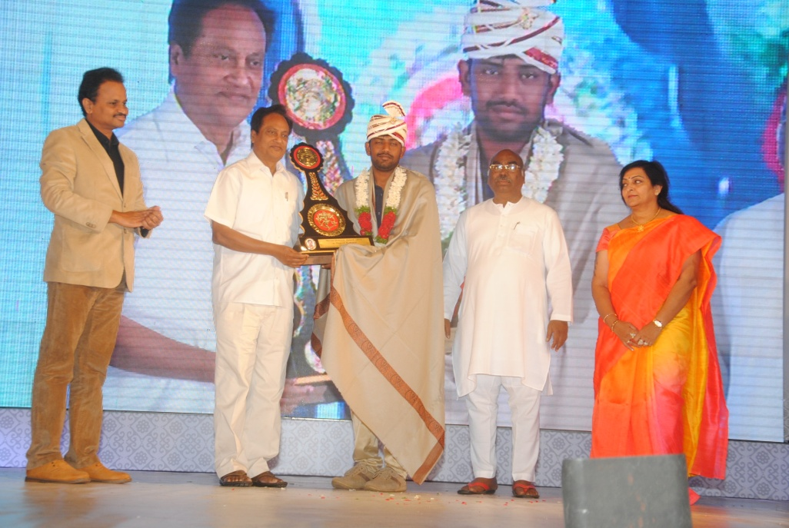
Vigyan ashram got many recognitions / awards during 2014-15.
- Shre Gama Vidhayak Krutishilta Purskar by Manus Prathisthan , Pune.
- Tatyasaheb Deshpande Purskar by Mahatma-Phule Co-op credit society (Mumbai).
- JIVAN SHIKSHAN – 2014 presented by KUL foundation, Pune for skill training in ruralareas.
- Sewa Dharmic Award 2015 by Chaitanya Art Theatres, Hyderabad (Telangana).
Rajshekhar Reddy accepting Seva Dharmik Award
We are thankful for encouragement from society.
I] Staff : Present strength of Vigyan Ashram staff is 37. During 2014-15, 11 new members joined VA team .
J] Management committee meetings
Vigyan ashram’s management committee comprises of Mrs.Mira Kalbag, Mr.Ashok Kalbag, Mr.Vijay Kumar, Mr.Sunil Kulkarni, Mr.Pravin Mahajan, Dr.Aruna Giri and Dr.Yogesh Kulkarni. The management committee meetings were held on 22nd March 2014, 30th July 2014, 17th January 2015 during 2014-15 for deciding on strategic, administrative and financial matters. Vigyan ashram is thankful to management committee members and Board of Trust of Indian Institute of Education for their support and guidance.

We are acknowledge support of various volunteers, IBT Schools, R & D institutes, students, alumni, staff members and Pabal villagers for their continues support and love.
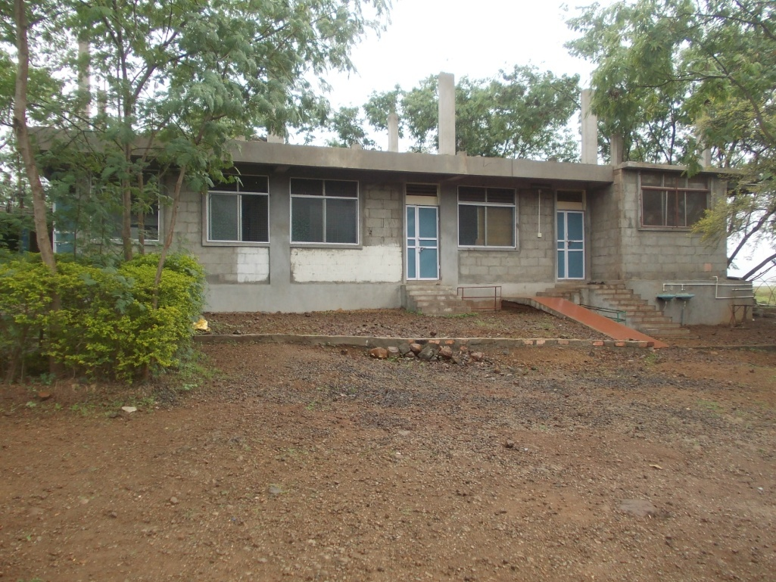
New Kitchen Building
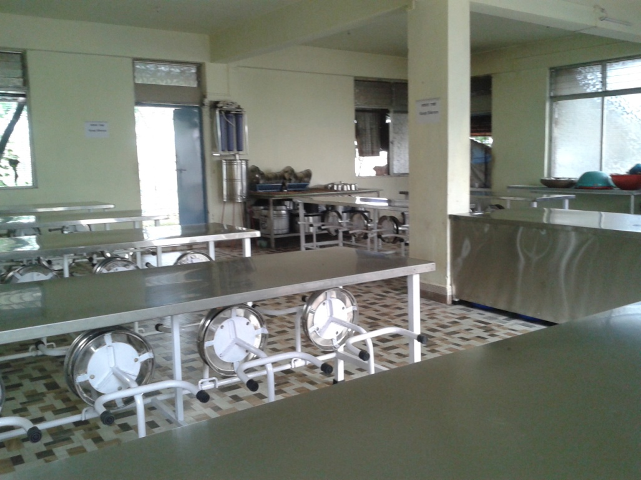
Kitchen furniture

